Owls
Term 3 “Down on the farm”

Dear Parents,

Our topic this term and next will focus on farms and the natural world. The children will learn about different types of farms and the produce that comes from them, helping them to understand where food comes from and how it is grown. We will also be learning about a variety of farm animals and their roles.
As part of our science learning, we will explore animal families and learn about life cycles, with a focus on frogs and hens. The children will begin to understand how these animals grow and change over time, and will have opportunities to observe and discuss these changes.
We are also very excited to be doing some hands-on learning. The children will plant their own seeds and learn how to care for them as they grow. In addition, we will spend time outdoors looking closely at wildflowers, helping the children to develop their observation skills and appreciation for nature.

Thank you for your continued support.

Mrs Roberts

COMMUNICATION AND LANGUAGE

KEY WORDS

Farm Crops
Growing Life Cycle
Planting Hatch
Cultivate Plough
Seed Exhausted
Lamb Compass
Calf Invertebrate
Hog Insect
Mare Udder
Foal cunning
Rooster dairy
Duckling pig sty
Hay bale pasture
Lifecycle murky
Carnivores stagnant
Omnivores shallow
Herbivores frogspawn
Toiling froglet
Industrious seed
worn-out stem
bad-tempered arable

MATHEMATICS
Volume and capacity
Reciting numbers to 100
Counting in 2s,5s,10s
Odd and even numbers
Doubling and sharing
Halves and quarters
Simple multiplication
LITERACY
We are covering these key texts:

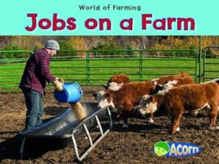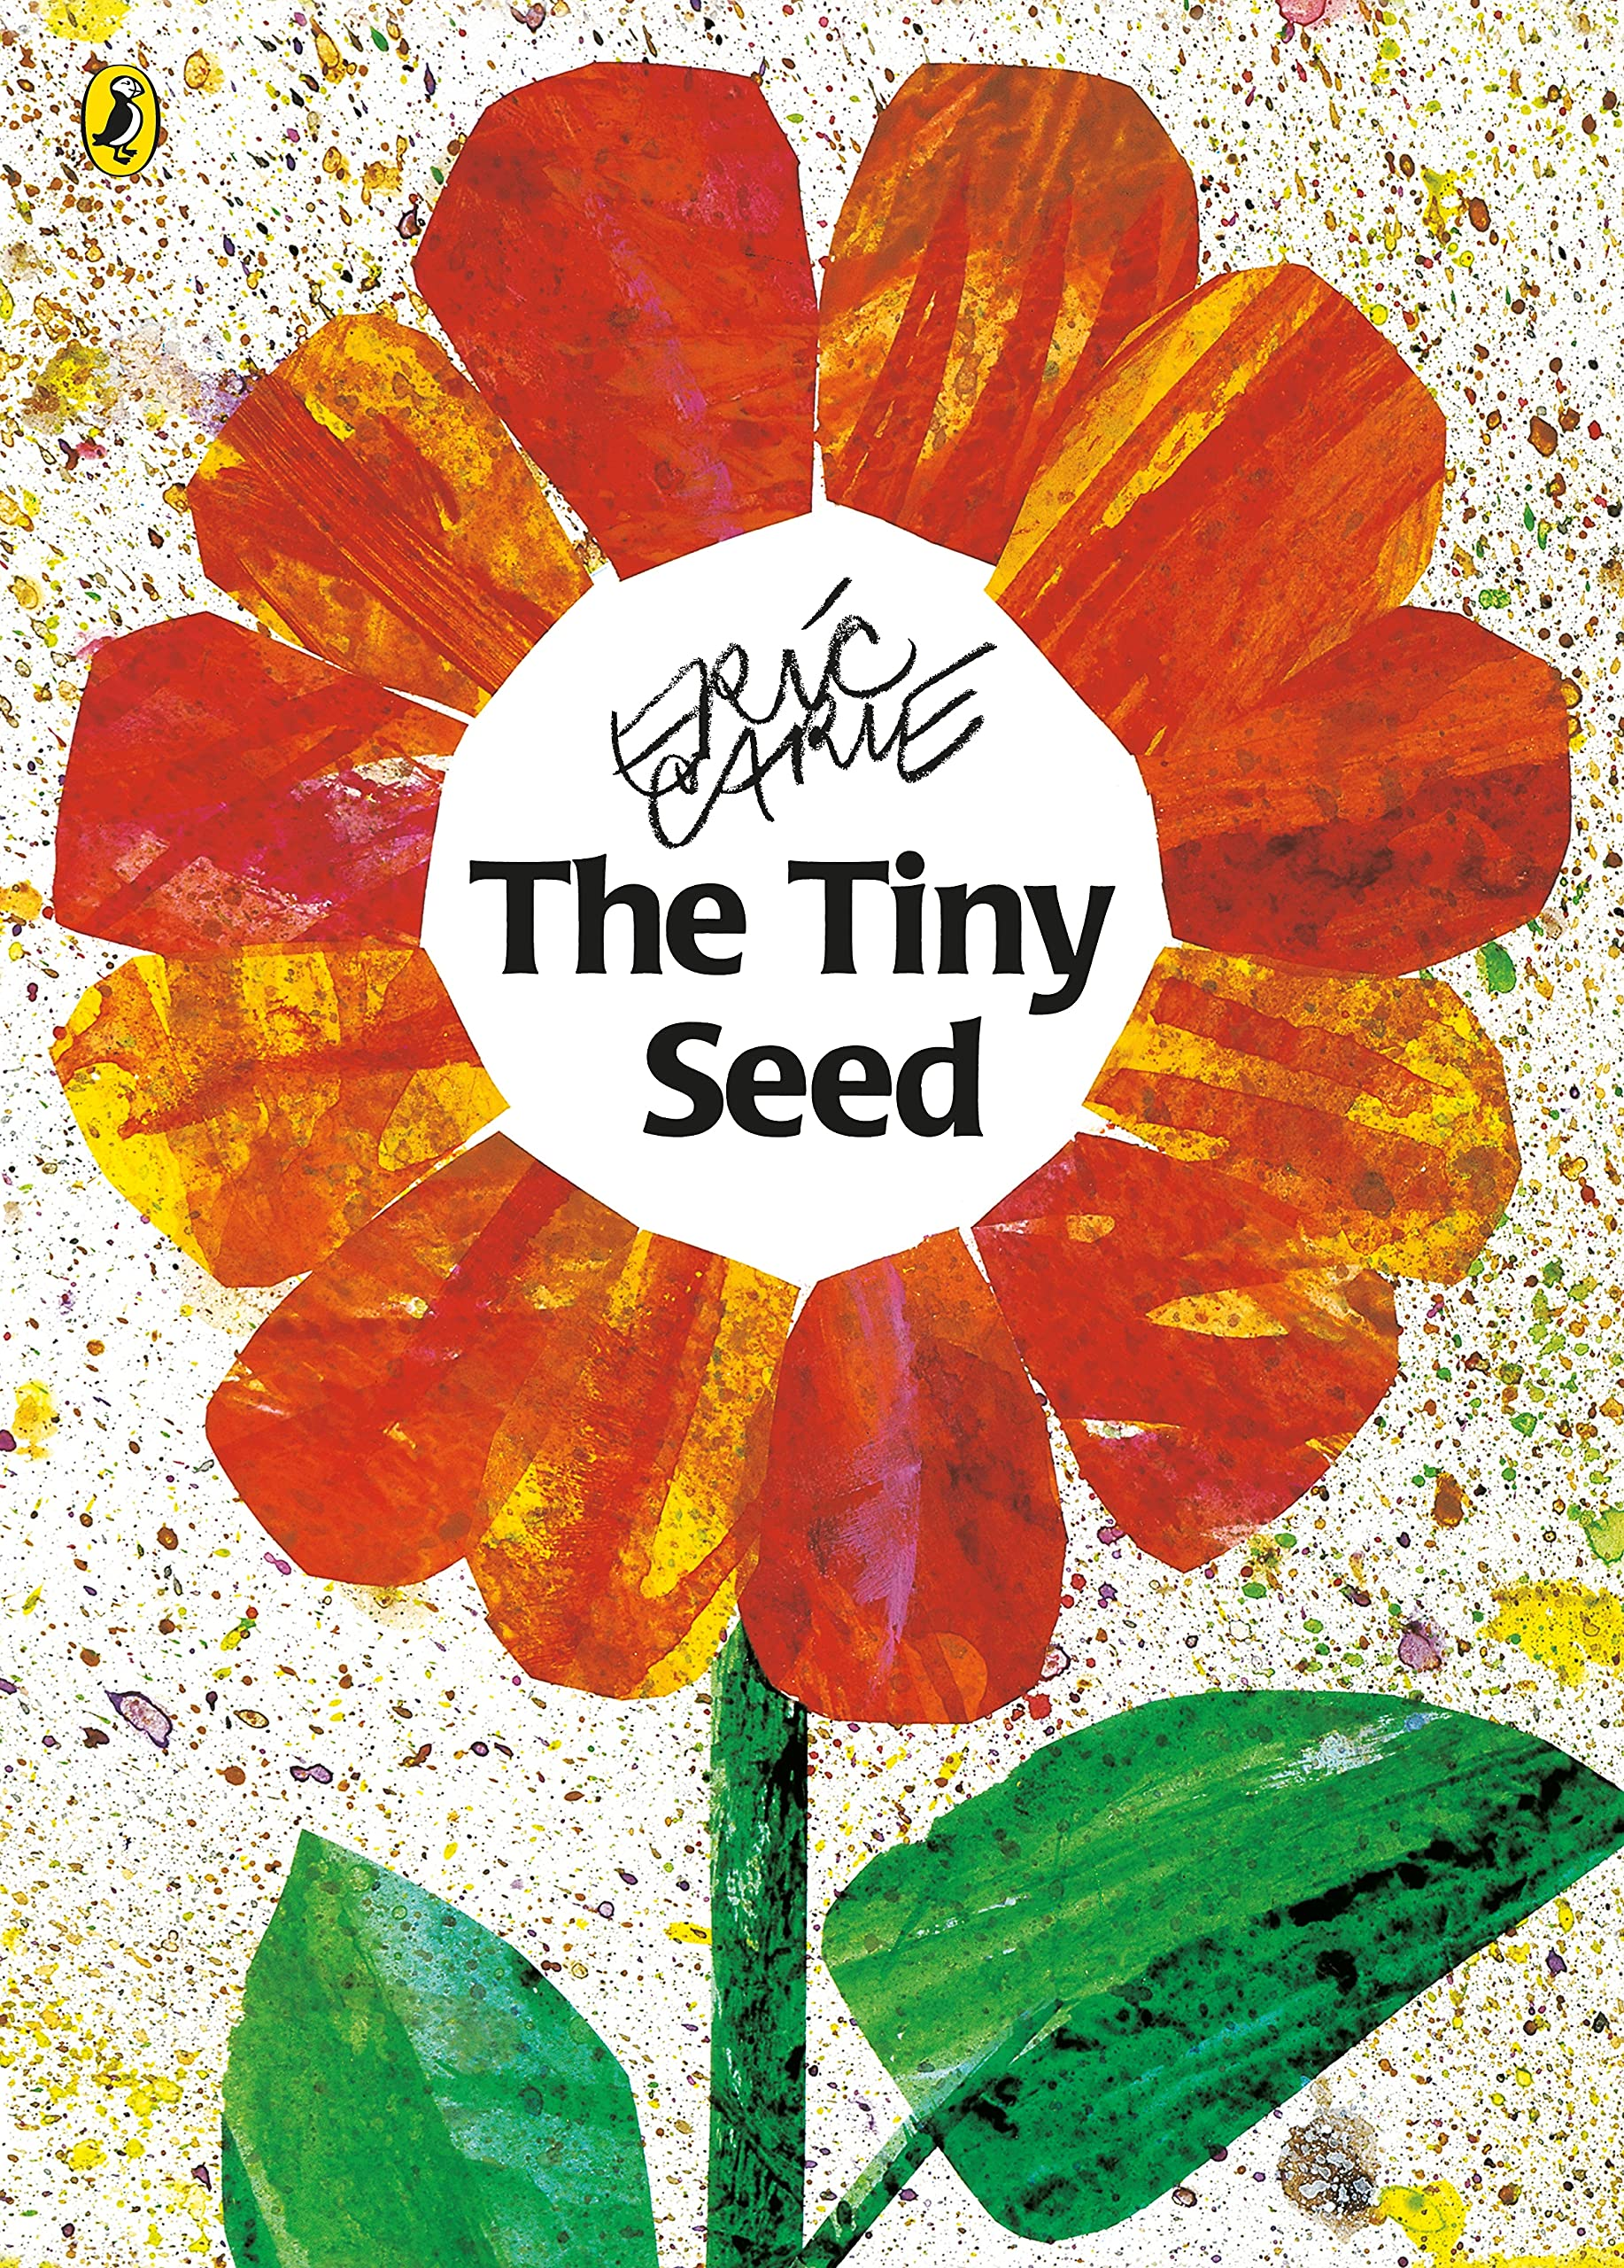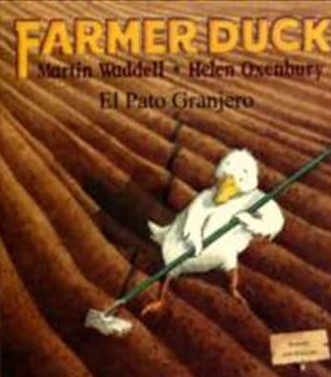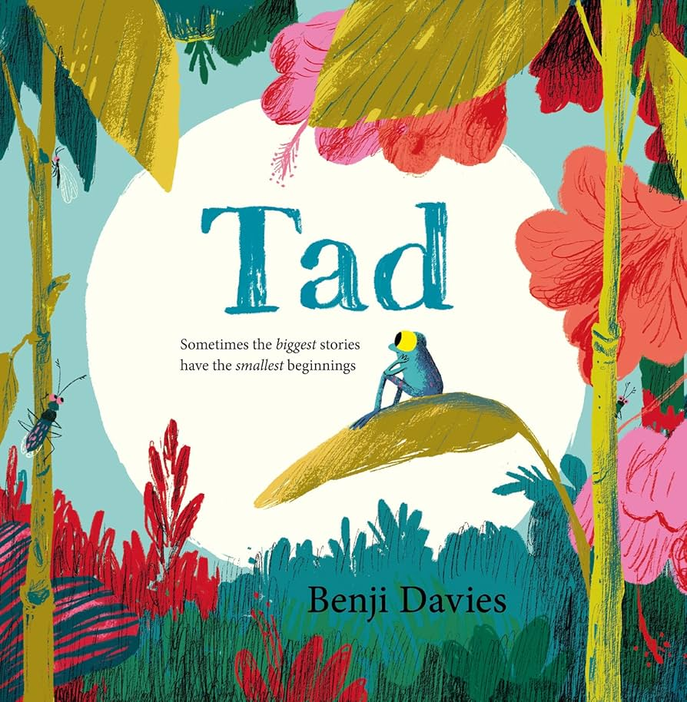

PSED
Healthy diet
Healthy lifestyle
Looking after our teeth
Why are private parts private
Staying safe online

LEARNING ENRICHMENT

A trip to a farm

RELIGIOUS EDUCATION
Why do Jewish families say so many prayers and blessings?
Hinduism: Ahimsa (non-violence, respect for life)
UNDERSTANDING OF THE WORLD
Types of farms
Machinery on farms
Adult and baby animals
Jobs on a farm
Gardening
Parts of a plant
A lifecycle of a plant
A lifecycle of a hen
A lifecycle of a frog
Rural vs urban
Amphibians
Reptiles
Carnivore/Herbivore /Omnivore
Evergreen and deciduous trees
Wild and garden plants
PHYSICAL DEVELOPMENT
Ball skills
Woodworking
Athletics
Sports Day

EXPRESSIVE ARTS AND DESIGN

Woodworking
Cooking
Making potato characters
3D art (making birds)
Acting out stories
Making music
Junk modelling

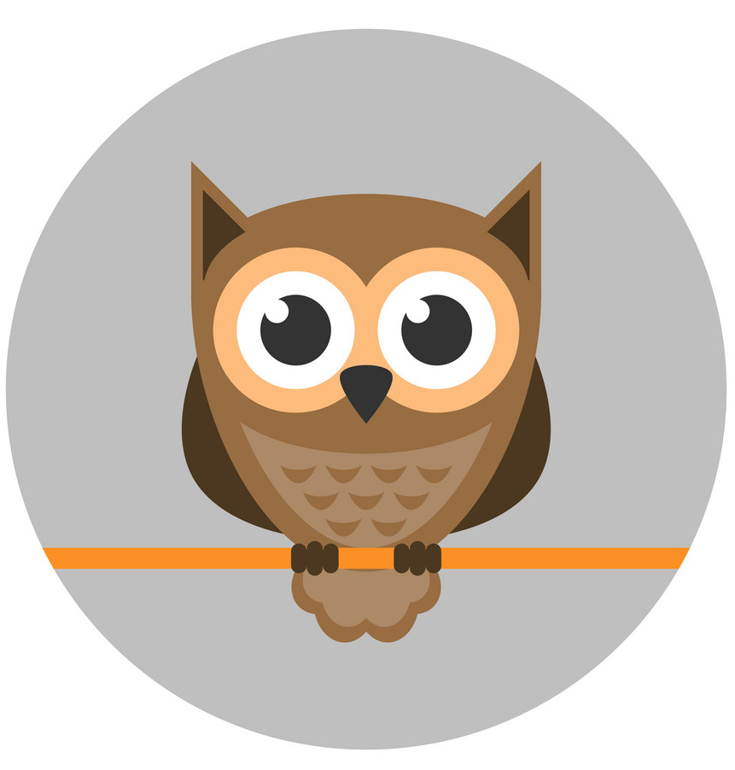Owls
Down on the farm


